*

Name : Yogesh Dinesh Joshi
Sap id : 590025632
Batch : 34
Teacher : Sugandha Sharma

Python Programming : Experiment 8

Objective 1 : Create a simple Tkinter window with a title and fixed size.
Code : 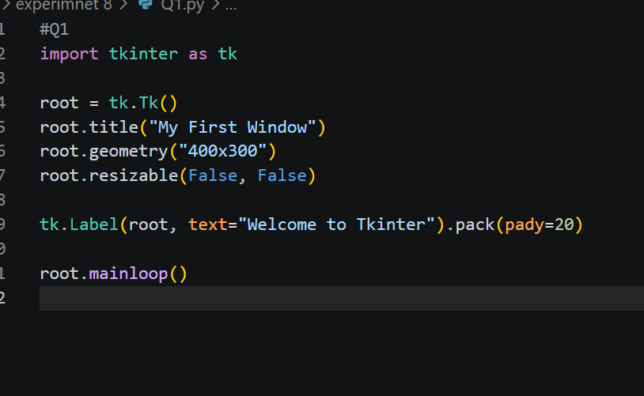
Output : 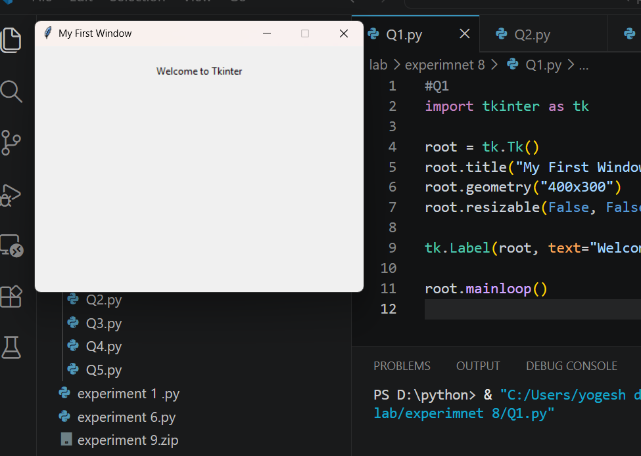
Objective 2 : Design a GUI based basic calculator for performing basic arithmetic operations.
Code : 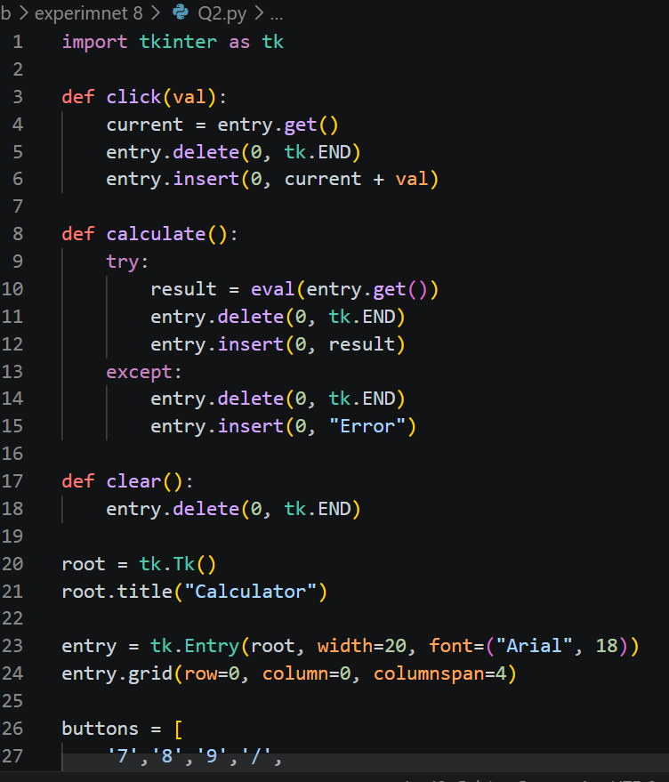
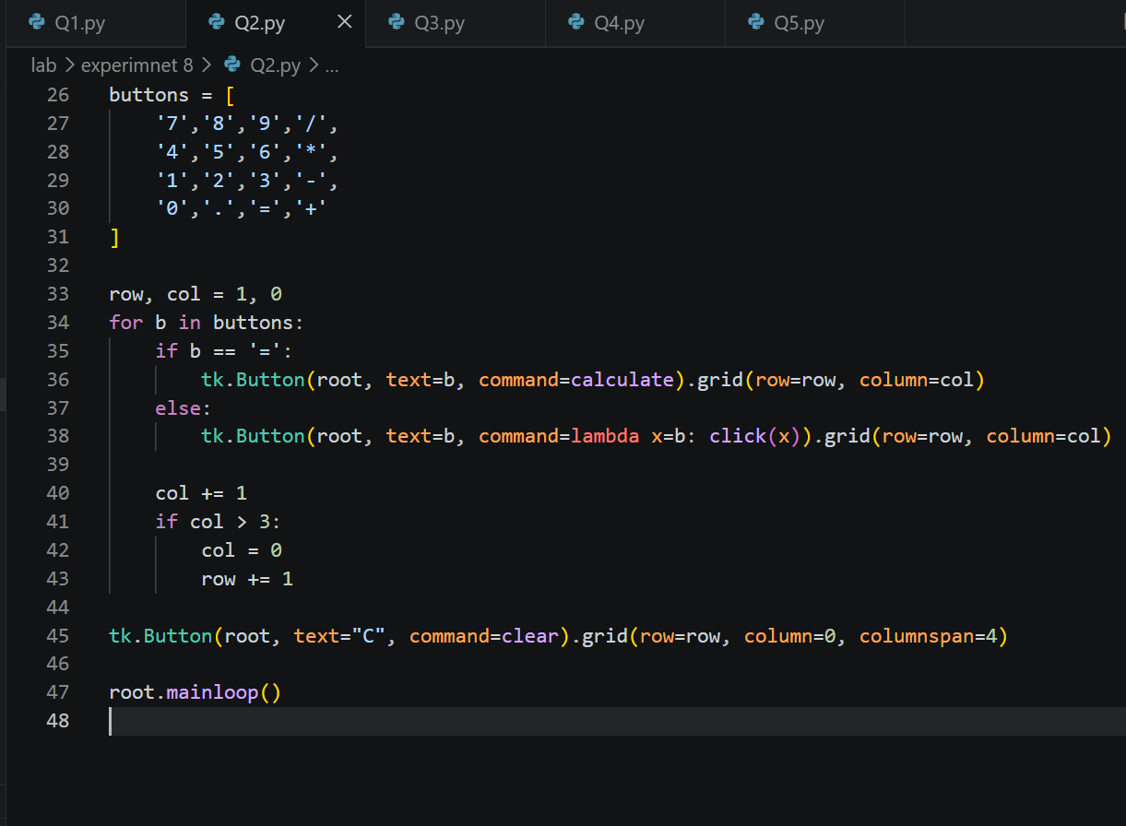
Output: 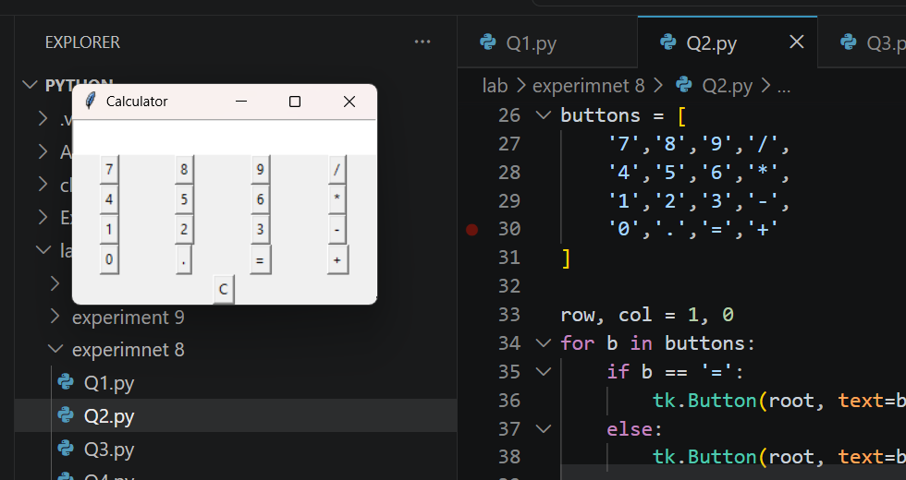
Objective 3 : Design a GUI for student registration for a course and store these details in a database. Use Tkinter for UI, SQLite/MySQL for database storage.
Code : 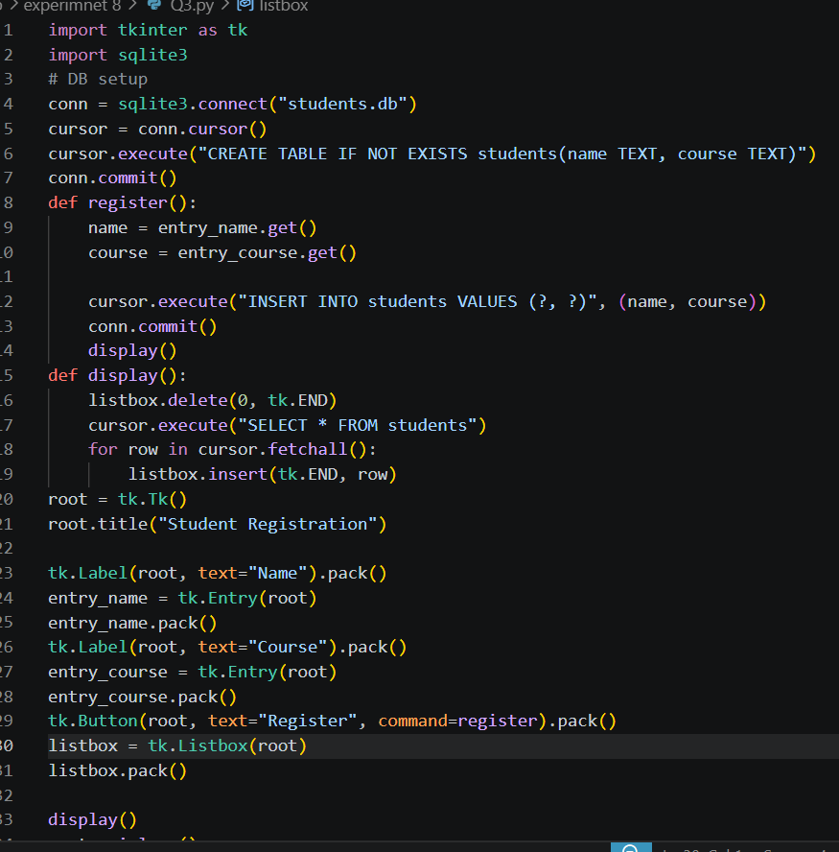
Output : 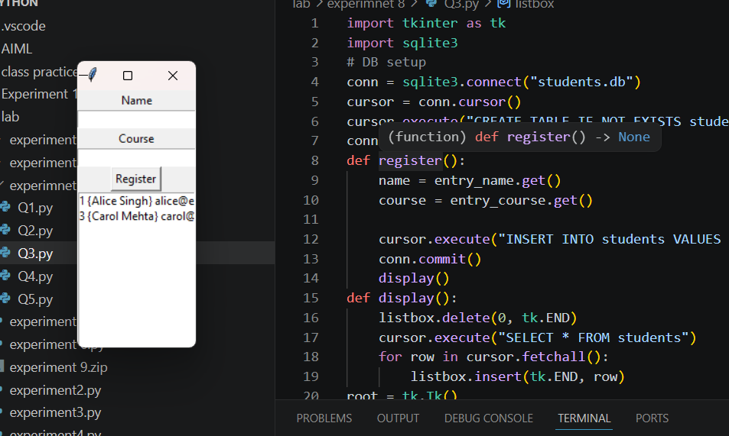
Objective 4 : Create a GUI based task manager where users can add, edit and remove tasks. Use Tkinter (buttons, listbox), SQLite/MySQL (task storage).
Code : 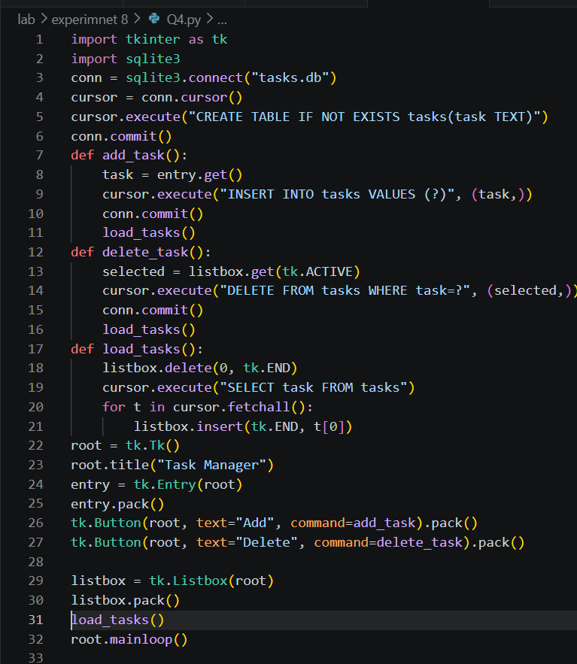
Output : 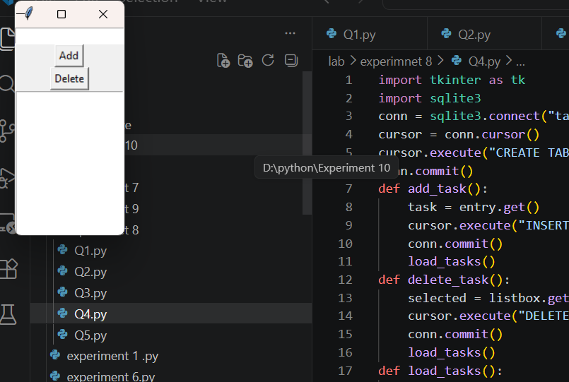
Objective 5 : Design a login and signup authentication system.
Code : 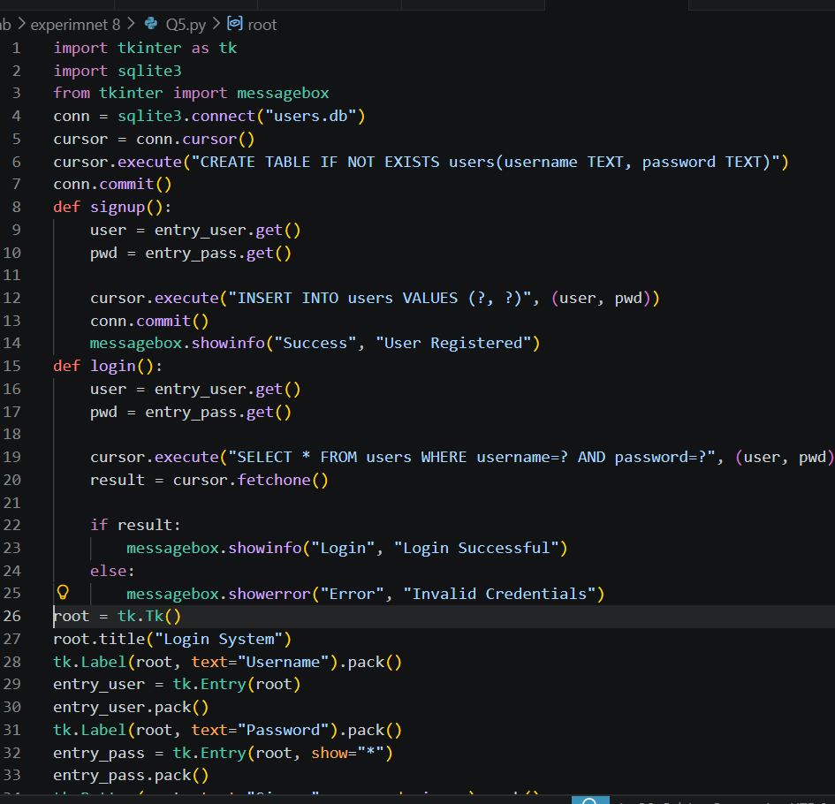
Output : 